Tugas 2

Nama : Adi Surya Fangidae
NIM : 055378839

File hasil pengerjaan tugas:
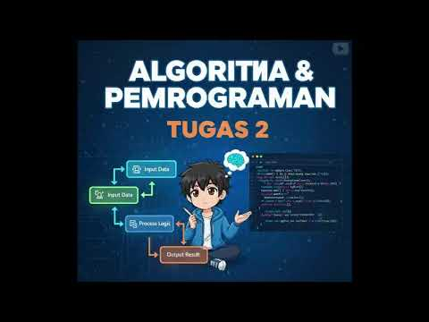
Link rekaman pengerjaan:

Hasil pengerjaan tugas:
import java.util.Scanner;
public class tugas2 {
public static void main(String[] args) {
// deklarasi variabel
Scanner input = new Scanner(System.in);
char golongan;
int jamlembur;
double gajipokok = 0, persenlembur = 0, gajilembur, totalgaji;
System.out.print("Masukan Golongan Karyawan (A/B/C): ");
golongan = input.next().toUpperCase().charAt(0);
System.out.print("Masukkan Jam Lembur: ");
jamlembur = input.nextInt();
// golongan
if (golongan == 'A') {
gajipokok = 5000000;
} else if (golongan == 'B') {
gajipokok = 6500000;
} else if (golongan == 'C') {
gajipokok = 9500000;
} else {
System.out.println("Golongan tidak valid");
System.exit(0);
}
// jamlembur
if (jamlembur == 1) {
persenlembur = 0.30;
} else if (jamlembur == 2) {
persenlembur = 0.32;
} else if (jamlembur == 3) {
persenlembur = 0.34;
} else if (jamlembur == 4) {
persenlembur = 0.36;
} else if (jamlembur >= 5) {
persenlembur = 0.38;
}
gajilembur = persenlembur * gajipokok;
totalgaji = gajipokok + gajilembur;
// outputhasilgaji
System.out.println("\n=== Hasil PERHITUNGAN GAJI ===");
System.out.println("Golongan : " + golongan);
System.out.println("Gaji pokok : Rp " + (int) gajipokok);
System.out.println("Jam lembur : " + jamlembur + "jam");
System.out.println("Gaji lembur : Rp " + (int) gajilembur);
System.out.println("Total penghasilan : Rp " + (int) totalgaji);
System.out.println("\n===== TERIMA KASIH =====");
System.out.println("\n===== ADI SURYA FANGIDAE 055378839 =====");
input.close();
}
}

